[Presenter’s Name]
[Title of Presentation]

Brookline Community Aging Network  Provides information to help residents remain engaged in the community.  Advocates to make Brookline an even better place to live for seniors and everyone.  Join us!  Founding Partners  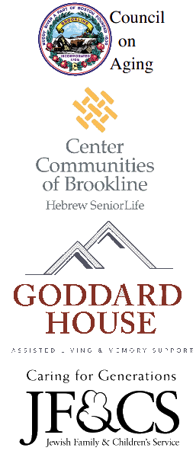 | [Photo or other image]  [Date and time] [Location – Room]  [Location – Building Name]  [Location Address], Brookline, MA  [Nine or ten lines of text (or less) about the presentation – use an easily read serif font, such as Times New Roman or Georgia, in 14 pt. or larger.]  Free of Charge – please call 617-730-7220 to register
www.BrooklineCAN.org

